SQL Queries (Balaji Food Sales Analysis)

1.Data Cleaning

* Removing Null columns which I won’t be using in the data analysis process

code:

ALTER TABLE balaji_sales

DROP COLUMN column11,column12,column13;

-before

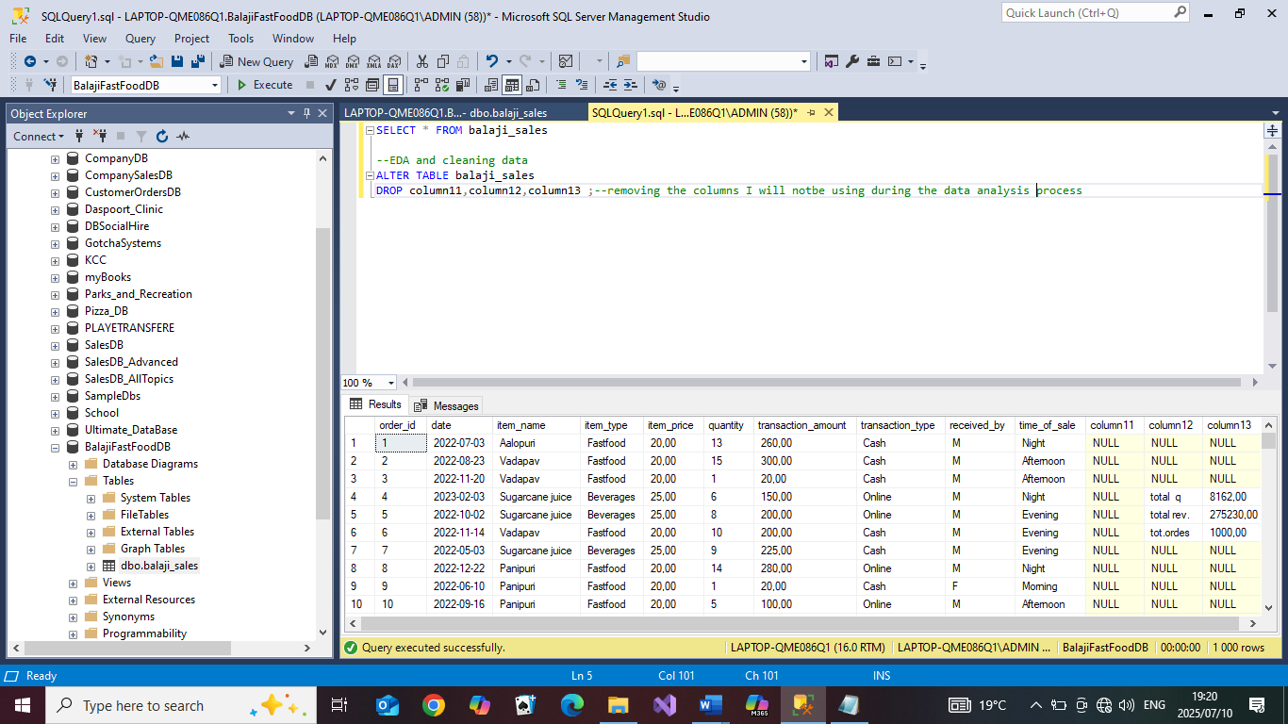

-results

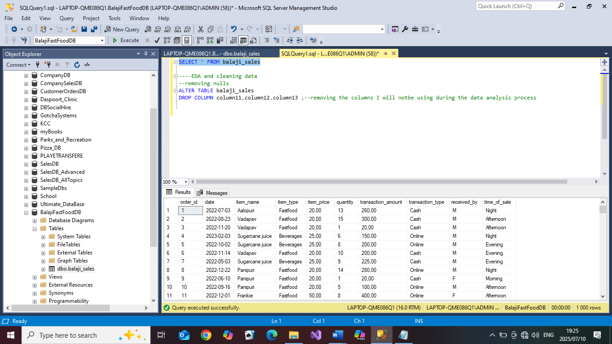

* Checking if other rows have Nulls in all columns

code:

SELECT * FROM balaji_sales WHERE order_id IS NULL

SELECT * FROM balaji_sales WHERE [date] IS NULL

SELECT * FROM balaji_sales WHERE item_name IS NULL

SELECT * FROM balaji_sales WHERE item_type IS NULL

SELECT * FROM balaji_sales WHERE quantity IS NULL

SELECT * FROM balaji_sales WHERE transaction_amount IS NULL

SELECT * FROM balaji_sales WHERE transaction_type IS NULL

SELECT * FROM balaji_sales WHERE received_by IS NULL

SELECT * FROM balaji_sales WHERE time_of_sale IS NULL

-results:

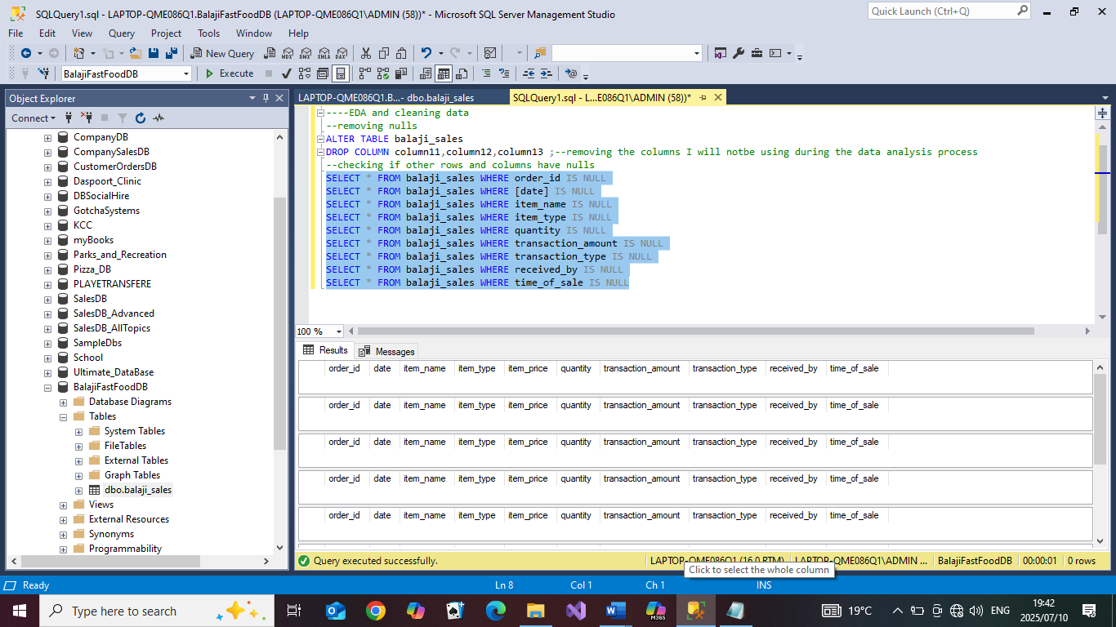

* Extracting and adding Day and Month Columns for trend analysis

Code:

ALTER TABLE balaji_sales

ADD DayOfTheWeek as DATENAME(DW,[date]),

MonthOfSale as DATENAME(MONTH,[date]);

SELECT * FROM balaji_sales

-results:

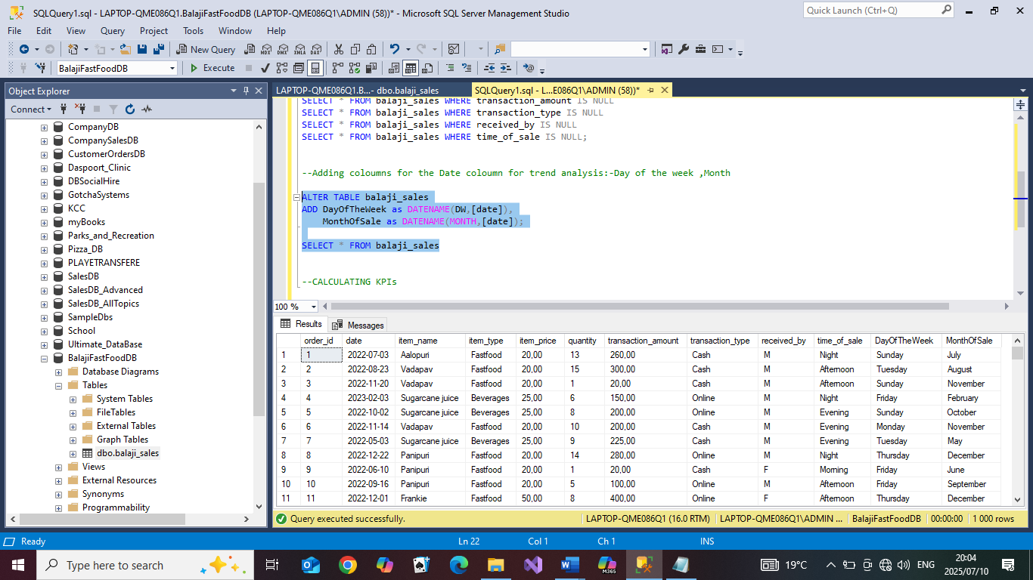

* Standardizing text in the gender column, changing ‘M’ to Male and ‘F’ to Female for more clarity

Code:

UPDATE balaji_sales

SET received_by='Male'

WHERE received_by='M'

UPDATE balaji_sales

SET received_by='Female'

WHERE received_by='F'

-results:

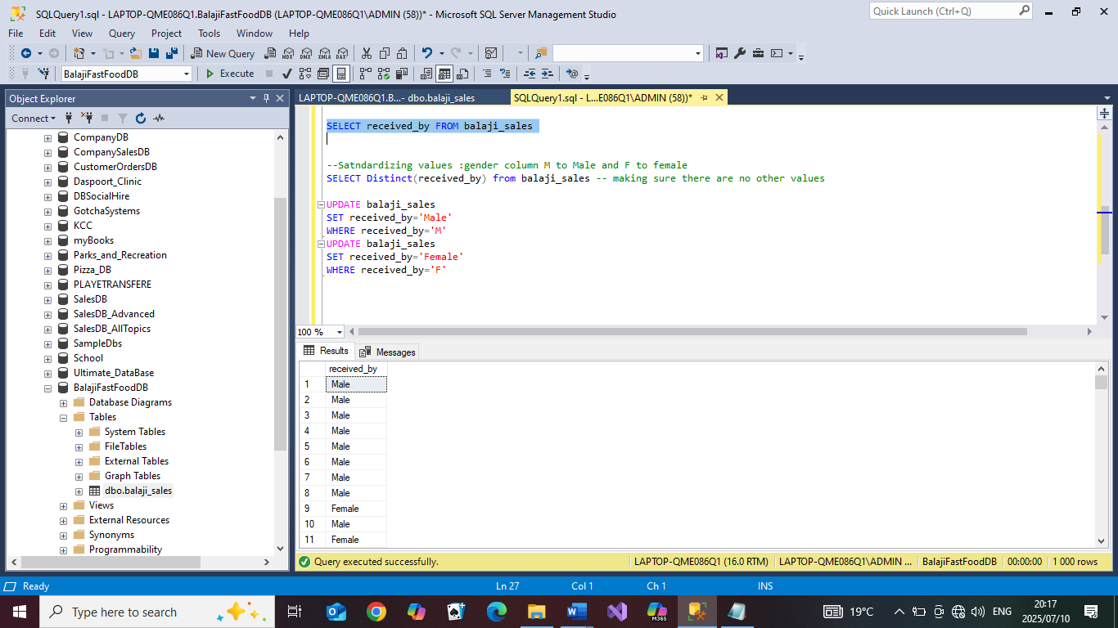

* Checking for duplicated values

code:

With dupls as (

SELECT order_id,date,item_name ,ROW_NUMBER() OVER(PARTITION BY order_id,date,item_name ORDER BY order_id) as RowNum FROM balaji_sales

)

SELECT * FROM dupls WHERE RowNum>1

-results:

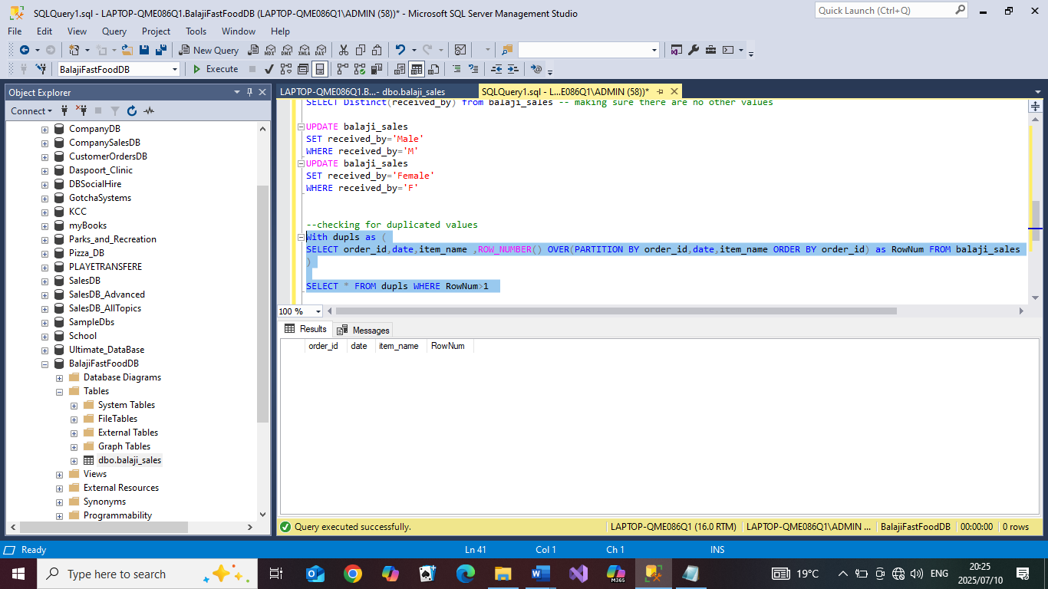

2.Calculating KPIs

1. Total Revenue For the Year

Code:

SELECT Round(SUM(transaction_amount),2) as [Total Revenue] FROM balaji_sales

-results:

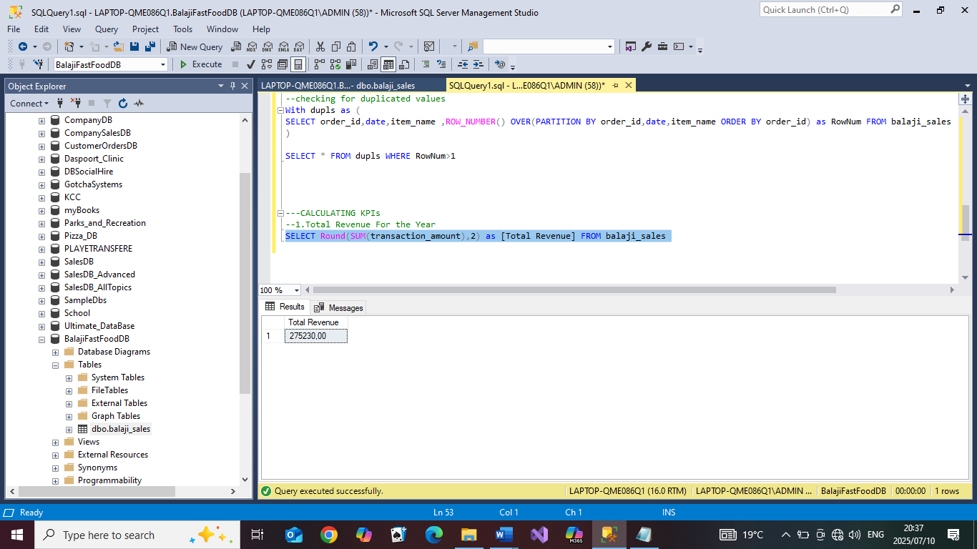

1. Total revenue on each item type

Code:

SELECT Round(SUM(transaction_amount),2) as [Total Revenue],item_type FROM balaji_sales GROUP BY item_type

-Results:

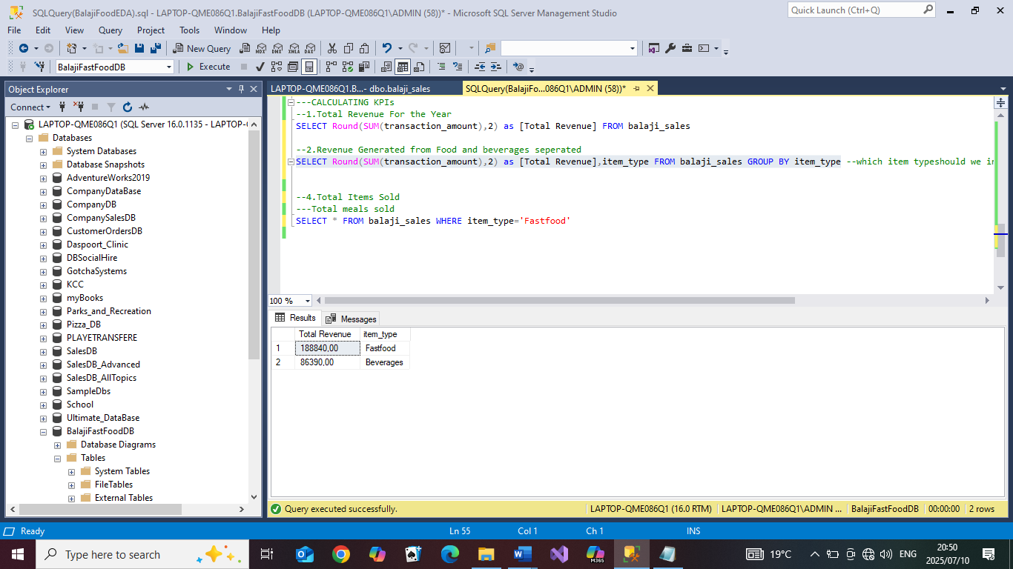

1. Total number of orders made

code:

SELECT COUNT(order_id) as [Total Orders] FROM balaji_sales

Results:

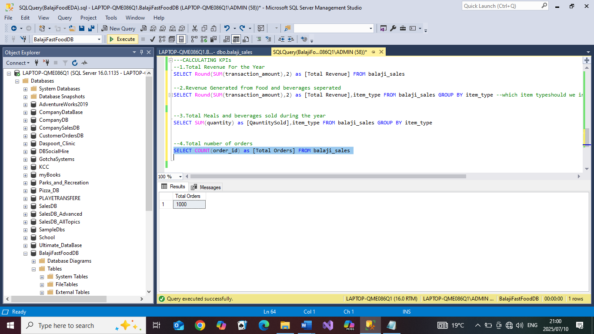

1. Total number of orders on each item type

code:

SELECT COUNT(order_id) as [Total Orders],item_type

FROM balaji_sales GROUP BY item_type

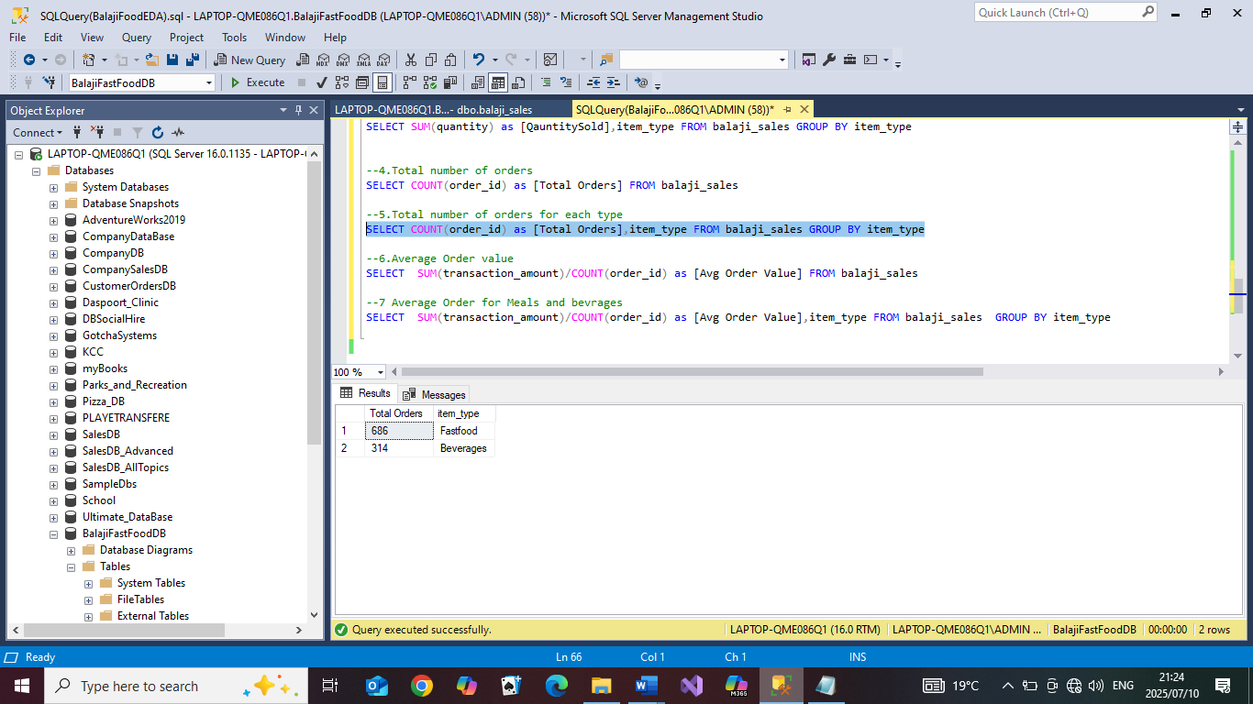

1. Average order value

Code:

SELECT SUM(transaction_amount)/COUNT(order_id) as [Avg Order Value]

FROM balaji_sales

Results:

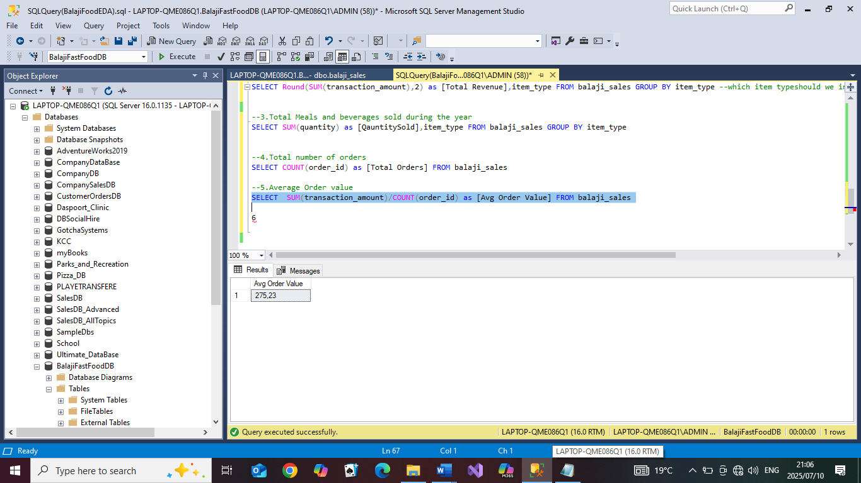

1. Average order value of each item type for the year

Code:

SELECT SUM(transaction_amount)/COUNT(order_id) as [Avg Order Value],item_type FROM balaji_sales GROUP BY item_type

Results:

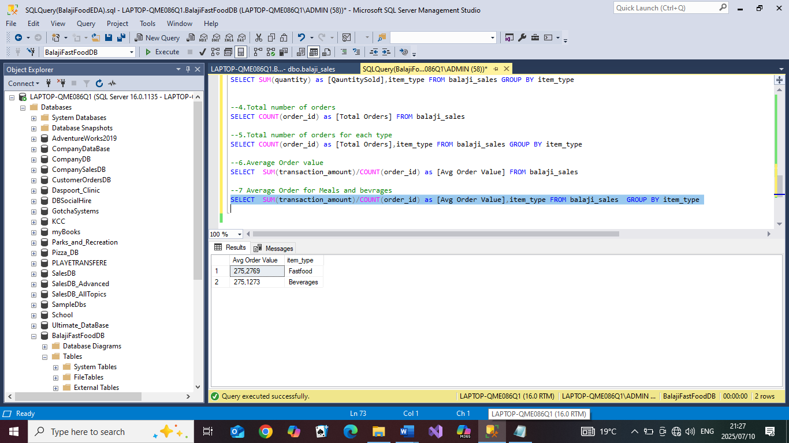

3.ANALYSIS

* Trend analysis

-Monthly Trends: Looking at revenue for each month

code:

SELECT SUM(transaction_amount) AS [Sales],YEAR([date]) as

[Year],MonthOfSale

FROM balaji_sales GROUP BY YEAR([date]),MonthOfSale Order by

YEAR([date])

results:

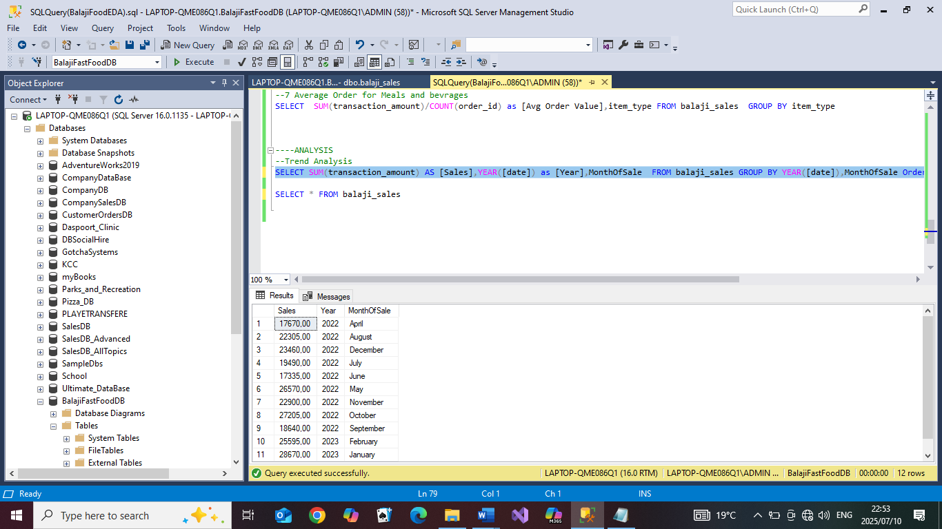

-Looking at the month with the most sales

code:

SELECT SUM(transaction_amount) AS [Sales],YEAR([date]) as [Year],MonthOfSale

FROM balaji_sales GROUP BY YEAR([date]),MonthOfSale

Order by SUM(transaction_amount) DESC

Results:

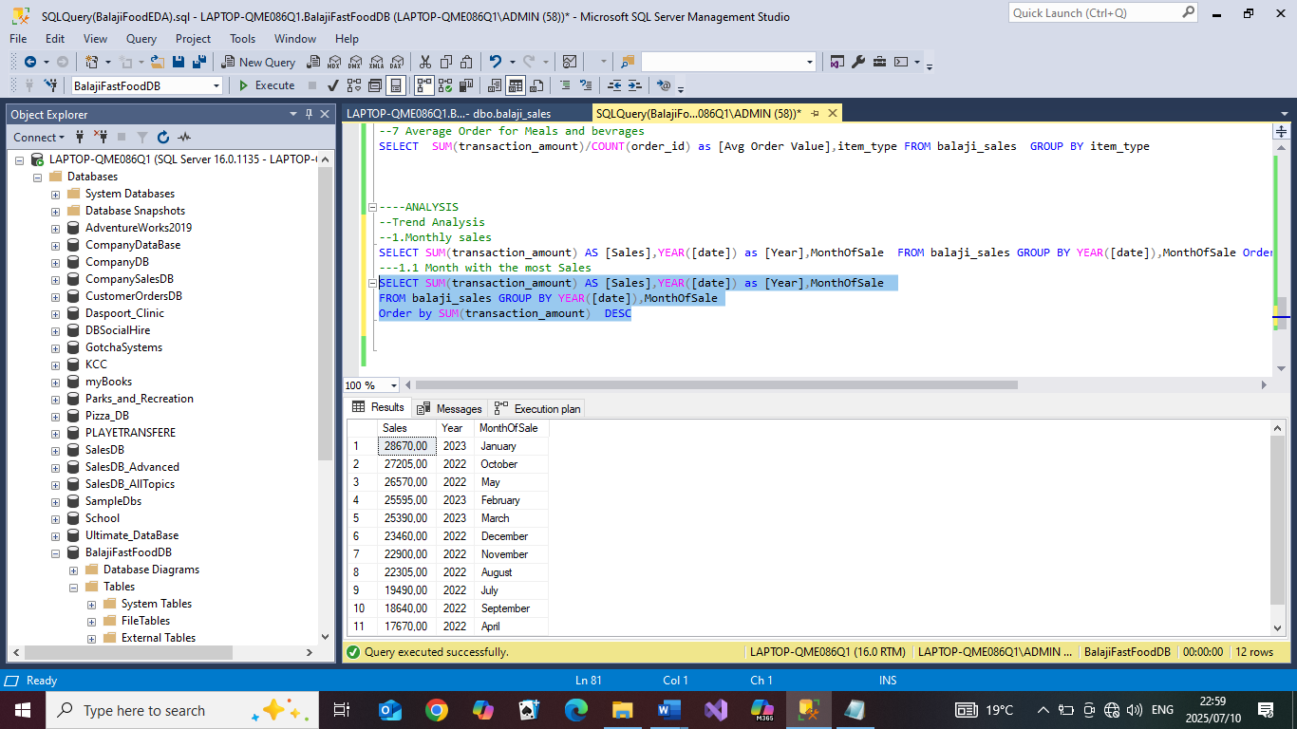

-Daily trend: Looking at the revenue generated over the year for each day and seeing which day generated the most amount of sales

Code:

SELECT SUM(transaction_amount) AS [Sales],DayOfTheWeek

FROM balaji_sales

GROUP BY DayOfTheWeek

ORDER BY SUM(transaction_amount) DESC

Results:

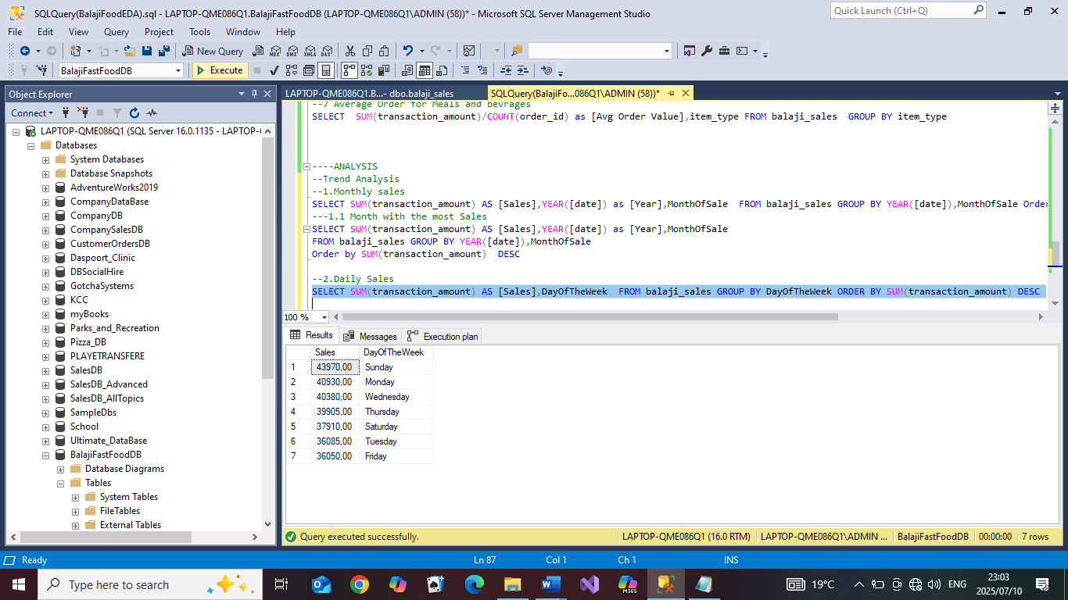

-Time of sale: Time during the day in which sales are being made

Code:

SELECT SUM(transaction_amount) AS [Sales],time_of_sale

FROM balaji_sales

GROUP BY time_of_sale

ORDER BY SUM(transaction_amount) DESC

results

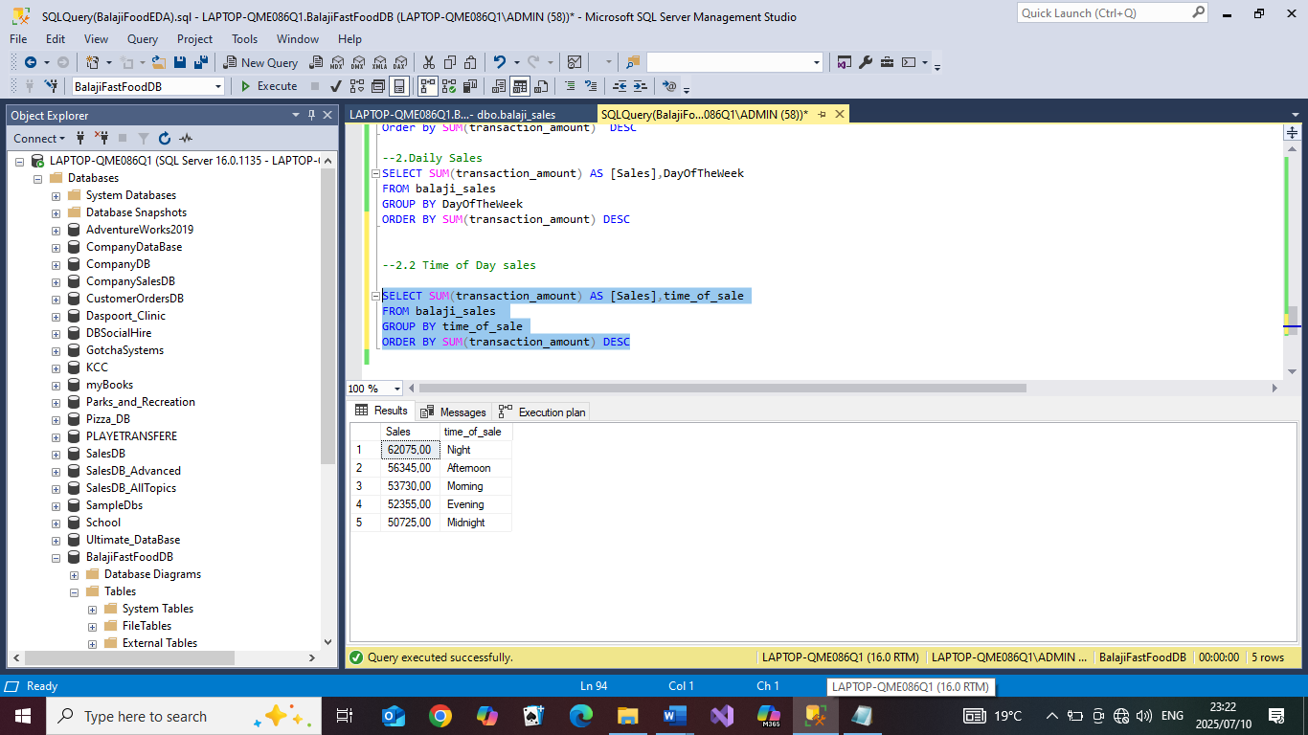

* Analysis: Looking at other factors not time bound that might affect sales

-Gender: Looking at gender and seeing which gender buys more

Code:

SELECT SUM(transaction_amount) AS [Sales],received_by

FROM balaji_sales

GROUP BY received_by

ORDER BY SUM(transaction_amount) DESC

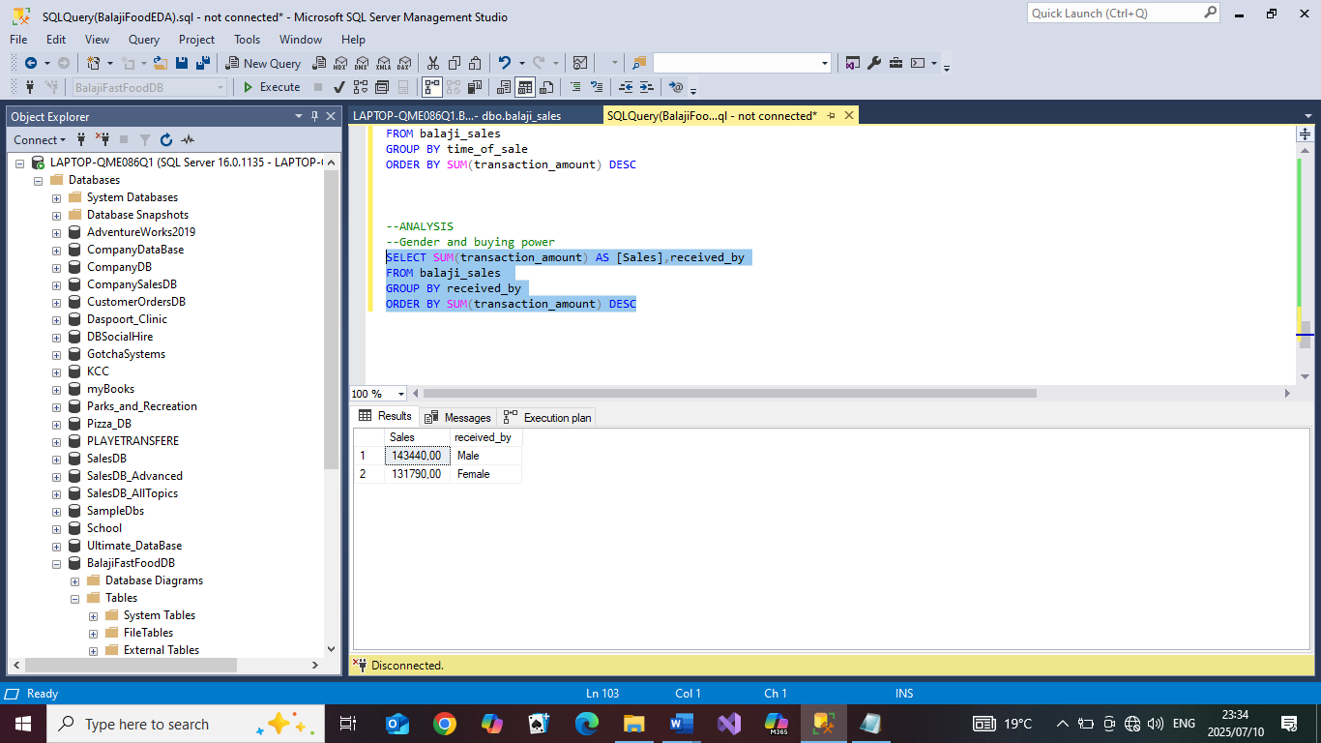

-Transaction type and its’ possible effect on sales

Code

SELECT SUM(transaction_amount) AS [Sales],transaction_type

FROM balaji_sales

GROUP BY transaction_type

ORDER BY SUM(transaction_amount) DESC

Results:

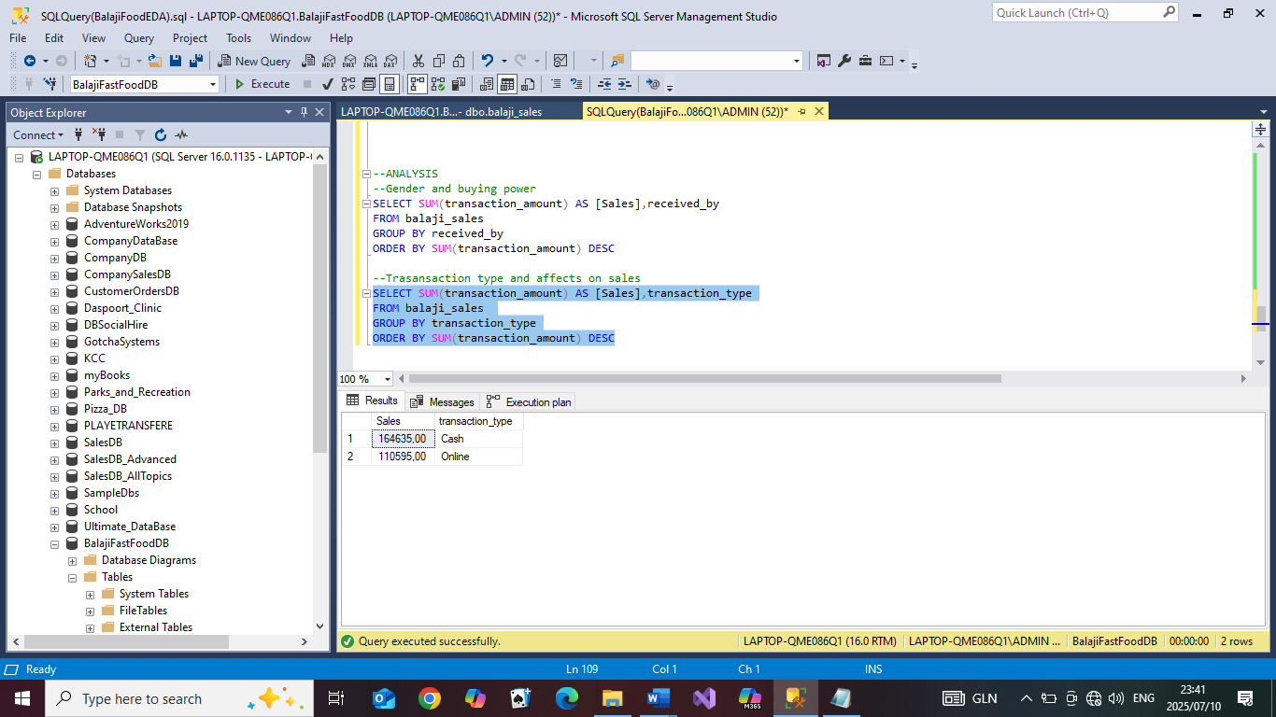

-Foods and drink types, and how they generated sales: Looking the top foods and top

drinks according to sales

Code:

SELECT SUM(transaction_amount) as [Sales],item_name

FROM balaji_sales

WHERE item_type='Fastfood'

GROUP BY item_name

ORDER BY SUM(transaction_amount) DESC

SELECT SUM(transaction_amount) as [Sales],item_name

FROM balaji_sales

WHERE item_type='Beverages'

GROUP BY item_name

ORDER BY SUM(transaction_amount) DESC

Results:

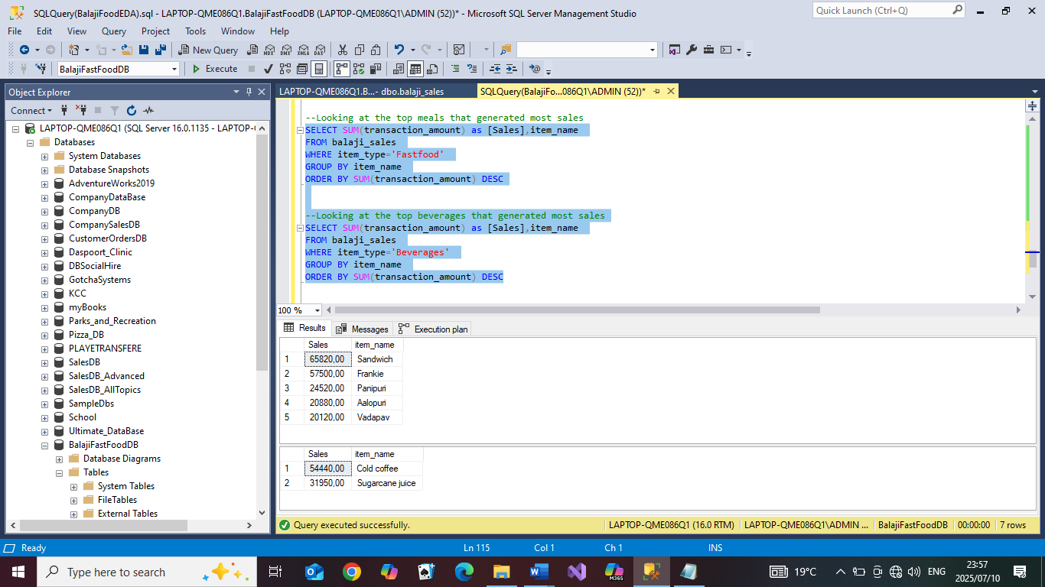

-Looking at the top foods and beverages that were bought the most over the year

Code:

SELECT SUM(quantity) as [Items Sold],item_name

FROM balaji_sales

WHERE item_type='Fastfood'

GROUP BY item_name

ORDER BY SUM(quantity) DESC

SELECT SUM(quantity) as [Items Sold],item_name

FROM balaji_sales

WHERE item_type='Beverages'

GROUP BY item_name

ORDER BY SUM(quantity) DESC

